# SPRINT THREE - Let’s Post to Facebook

Two things to always remember: Save Often, Compile Often – this will save you a lot of heartache

*Note: Type in all the code when you are instructed to. You will learn much more by typing it in yourself! Also type it in EXACTLY as you see it, capitalization included. Code is case sensitive so every space and lower case/upper case letter matter. If you get stuck and are having errors please copy and paste the code directly. Also there are a few spots where I recommend copy and pasting instead of typing so look for those!*

We our now going to link everything together and create our Facebook post!

1. Double click the “MyServlet.java” file.
   1. Located in the Source Packages/FacebookSource folder.
2. The first thing we are going to do is create the Facebook call to publish our message from our text box to our own personal news feed.

HINT: when copy and pasting if the right click is giving you issues just use the top menu and perform an “Edit/Paste” action instead.

|  |  |  |
| --- | --- | --- |
| STEP ONE – COPY AND PASTE CODE | | STEP TWO – YOUR SCREEN SHOULD LOOK LIKE THIS |
| FacebookType publishMessageResponse = facebookClient.publish("me/feed",FacebookType.class, Parameter.with("link", "https://hiremadskills.com"),  Parameter.with("message", request.getParameter("FBStatus"))); |  | |

*Now save, instead of clicking the green arrow let’s click the hammer icon. This will compile our code to make sure we don’t have any errors without actually displaying the web page. Click “ok” when the pop-up box is displayed.*

1. Now let’s update the form we created in Sprint Two to display a custom message with our Facebook parameters.

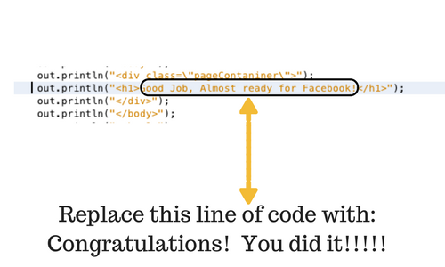

*Now save and click the green arrow and make sure you are able to compile.*

1. Now type in this line of code just below the code you changed above:

|  |  |
| --- | --- |
| STEP ONE – TYPE IN CODE | STEP TWO – YOUR SCREEN SHOULD NOW LOOK LIKE THIS |
| out.println("<h2>A new Facebook status has now been sent to Facebook for: " + user.getName() + "</h2>"); |  |

1. Now type this line below the line you entered in step 4.

|  |  |
| --- | --- |
| STEP ONE – TYPE IN CODE | STEP TWO – YOUR SCREEN SHOULD NOW LOOK LIKE THIS |
| out.println("<h2>Your updated status is: " + request.getParameter("FBStatus") + "</h2>"); |  |

*Now save and click the green arrow and make sure you are able to compile. You should now see your browser window with your fully functioning form!*

# Are you ready to test your Facebook status?

1. *Type a new Facebook Status in your textbox. Be sure to include #madskillshackathon in the box so we can all see your status update!!*
2. *Click the “Update Status” button*
3. *You should now see this (It should have your name and your new status on it):*

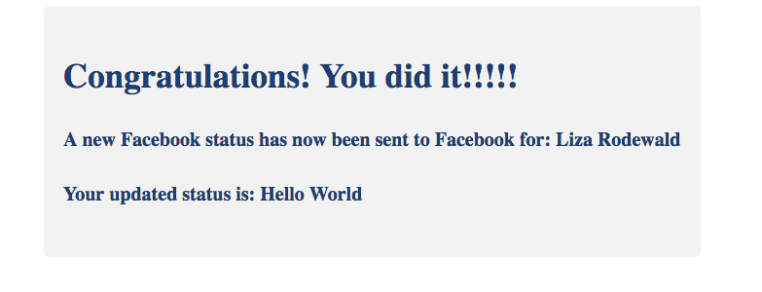

Go to your Facebook news feed and check it out. Pretty cool huh?!

Meet me back on Facebook Live for our final wrap-up and giveaways!!